III. Overall functionality of the DEX client program

DEX is an open-source, distributed software program that is assigned a unique ID number each time it is installed, which is the only thing identifying it to other clients. Once opened, it has a main menu screen with a few configuration switches, and at least four other user interface screens accessible via the menu.

Besides the user interface screens, six other components “under the hood” of DEX exist to run as subsystems and facilitate trading for all other peers in range. Taken together, DEX is a complete system node with no other type of software needed to run the entire system smoothly. (No central servers, no cloud storage, no Miners, etc.)
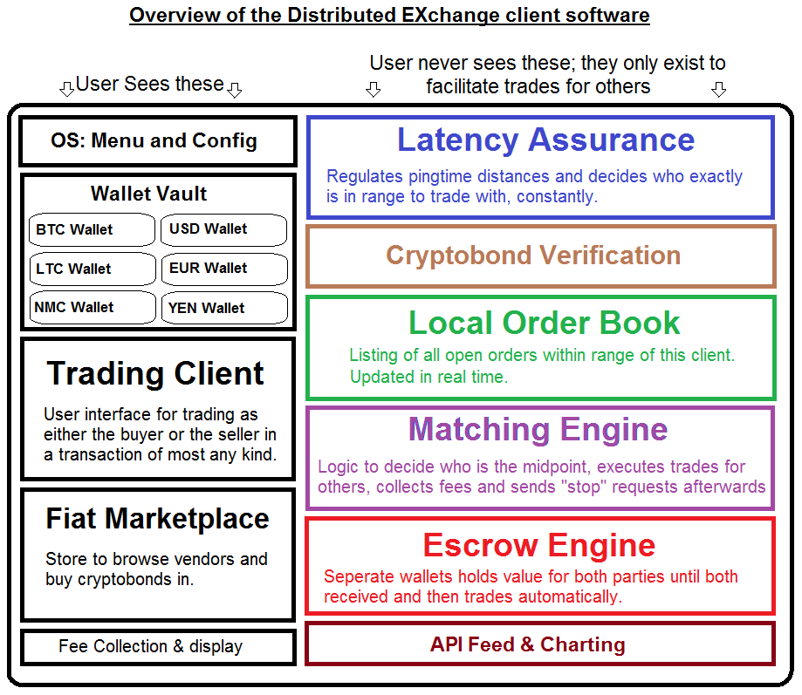
A bitcoin wallet program is just one of many wallet programs inside of the 'vault' (wallet display area with added security) which is one of 5 UI screens inside the client program as far as the user is concerned.

From the main menu at startup, which may list simple information like the status of connections and today's price for a bitcoin, there will be four other screens they will see that allow them to access all of the functionality of the client, from buying cryptobonds to trading them in real time, to accessing their wallets, to even reviewing their earned income. The four UI menu options are:

A. The Wallet Vault
This page shows all currency wallets contained within this DEX client, stored side-by-side. Clicking on any one of them will take the user inside that wallet to use it like a bitcoin wallet, including sending and receiving that currency from there. Yes, you can even go inside your “USD” wallet and send some directly to a friend across the globe if you would like.

Each wallets is optionally password protected, as is the entire wallet vault by default.

B. The Trading Client
Opening this screen will take the user directly into a Mt.Gox-like trading platform that allows the user to select his or her currency pair and view the graph, bid, and ask prices in real time. Only currency that exists in this client's wallets now are available for trade here.

C. The Fiat Marketplace
Opening this screen will display a vendor marketplace for the user to purchase cryptobonds in. It will be complete with sortable ratings and limits, and allow the user to purchase cryptobonds in any currency very efficiently.

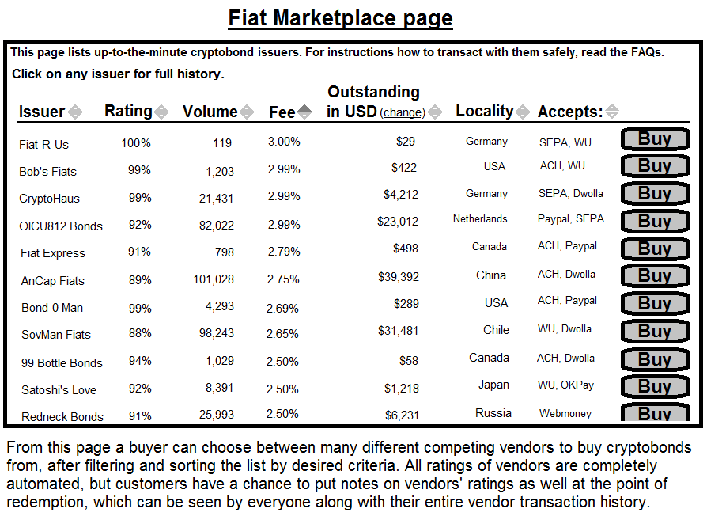
D. Fee Display
This simple screen shows the results of any fees earned for being the middleman in other peoples' transactions. It then lists details about all transactions such as the time and amounts earned, userIDs of the clients that traded, and anything else pertinent to that transaction, in the case of a rare instance where 3rd-party evidence is needed. (Just leaving that option open for 3rd party courts to use.)

Meanwhile, the suite of supporting applications 'under the hood' of the client program represents most of the code, and exists as much for other DEX clients to access as it does for the one its' on.

Those six modules are:

A. Latency Assurance
This program is in charge of continually polling your IP “neighborhood,” and deciding which other DEX clients are “in range.” If the development team feels that 200 milliseconds, for instance, is the best time to set across all clients for proper functionality, then that is the limit of time a ping should take travelling from one DEX client to another, in order to assure speedy and safe transactions.

To this end it will be constantly sending and receiving pings to all other DEX clients and using simply logic to choose who is in range.

B. Cryptobond Verification
This part of DEX is in charge of watching all of the cryptobonds' public addresses on their blockchains, and verifying that the collateral inside each cryptobond has not be removed prematurely. In short, this is the part that watches to make sure vendors are honest. Polling time could be optional in the main menu configuration.

C. Local Order Book
The local order book not only lists the buy and sell orders (pending and some history) available from the peers in its' acceptable pingtime distance, it also consolidates all of the trade orders listed at those peers too.

This two-generation view of all available trades is kept in real time by accepting both “start” and “stop” signals from all of the clients it can see, and includes all of the trade requests in each of these client's local order books too.

(Diagram on next page)

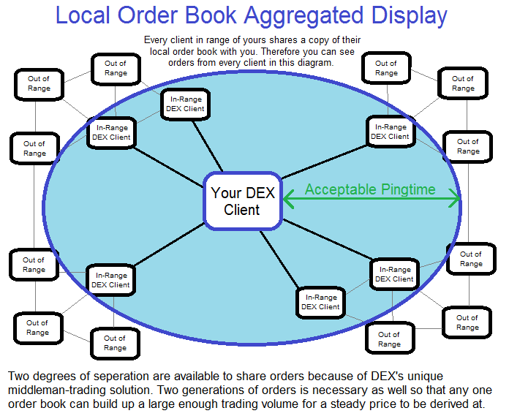

D. Matching Engine
The most dynamic part of this system will be the trade matching engine. It constantly watches the local order book to decide if this client is indeed the shortest interval between each buyer and seller pairing. If so, it triggers a trade, sending a “trading now” signal to all clients in range, and makes itself the middleman for interfacing with the Escrow engine.

As it completes the matching of each trade for others, it sends out a “stop” request to all order books in range to let them know this trade is no longer available, and collects the standard fee from escrow and deposits it in the appropriate wallet.

Note: The matching engine on a given client is never used at all to match any orders as either the buyer nor seller on the same client.

E. Escrow Engine
The Escrow engine is some basic logic with another set of wallets. It has one wallet for each type of currency, and it holds other people's money as it waits for the 2nd of two in each trade to arrive, so the matching engine can execute the trade. It will employ a 2-of-3 signature security function that will not let the money be released to any party without approval of at least two signatures from the three involved parties.
If some kind of problem such as a dispute occurs, the logic in the escrow engine can reverse the trade without signatures or in certain cases could even halt the trade and alert the user by flashing a warning screen up on the front page with instructions on how to get this trade completed. With no central authority, this is a vital task and realistically users will have to be involved in other people's disputes from time to time... Which is why the middleman deserves a standard fee.

Note: Like the matching engine, the escrow engine cannot be used on any orders as either the buyer nor seller on the same client.

F. API Feeds & Charting
The trading client pulls its' graphical charts of the data from this module, which both acts as the graphic display processor for all graphs here, as well as the source of this client's API feed.

API feeds are offered from each client for others to view, so that a view of that local market, from that client's perspective, can be watched. This is much like how today we can view the MtGox API feed, in places like http://bitcoin.clarkmoody.com and even port the feed into 3rd-party trading platforms.

Note: For every DEX client, there is an individual API Feed that shows the price of each security in real time in their region. This means that with a few feeds displayed together on one page somewhere, such as a site like blockchain.info, we can easily derive a worldwide average for that currencies' price.

